Topic : Library Management System  
You are going to build a project based on Library Management System. It keeps track of all information about books in the library, their cost, status and total number of books available in the library.  
  
Create a database named library and following TABLES in the database:   
  
1. Branch   
2. Employee   
3. Books  
4. Customer  
5. IssueStatus  
6. ReturnStatus   
  
Attributes for the tables:   
  
1. Branch  
  
• Branch_no

* Set as PRIMARY KEY    
  • Manager_Id    
  • Branch_address    
  • Contact_no

2. Employee    
  
• Emp_Id – Set as PRIMARY KEY    
• Emp_name    
• Position    
• Salary  
• Branch_no

* Set as FOREIGN KEY and it refer Branch_no in Branch table

3. Books    
  
• ISBN

* Set as PRIMARY KEY    
  • Book_title    
  • Category    
  • Rental_Price    
  • Status [Give yes if book available and no if book not available]    
  • Author    
  • Publisher

4. Customer    
  
• Customer_Id

* Set as PRIMARY KEY    
  • Customer_name    
  • Customer_address    
  • Reg_date

5. IssueStatus    
  
• Issue_Id

* Set as PRIMARY KEY    
  • Issued_cust – Set as FOREIGN KEY and it refer customer_id in CUSTOMER table  Issued_book_name   
  • Issue_date   
  • Isbn_book – Set as FOREIGN KEY and it should refer isbn in BOOKS table

6. ReturnStatus    
  
• Return_Id

* Set as PRIMARY KEY    
  • Return_cust    
  • Return_book_name    
  • Return_date    
  • Isbn_book2
* Set as FOREIGN KEY and it should refer isbn in BOOKS table

Display all the tables and Write the queries for the following :  
  
1. Retrieve the book title, category, and rental price of all available books.



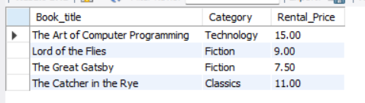

2. List the employee names and their respective salaries in descending order of salary.

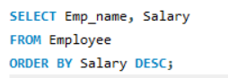

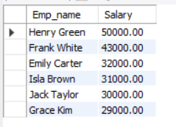

3. Retrieve the book titles and the corresponding customers who have issued those books.

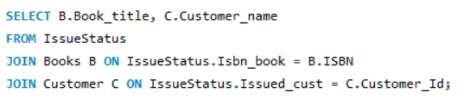

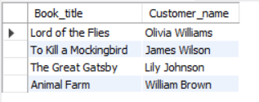

4. Display the total count of books in each category.

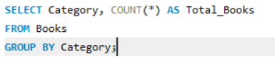

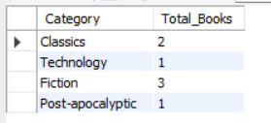

5. Retrieve the employee names and their positions for the employees whose salaries are above Rs.50,000.

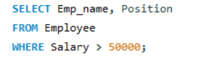

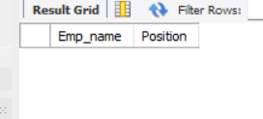

**(No employee with salary above rs.50000.)**

6. List the customer names who registered before 2022-01-01 and have not issued any books yet.

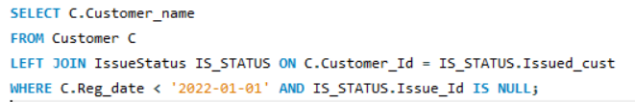

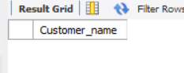

**(No customers who have registered before 2022-01-01 and haven’t issued any book yet)**

7. Display the branch numbers and the total count of employees in each branch.

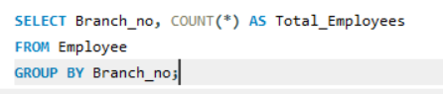

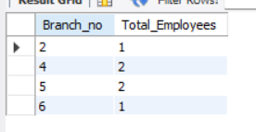

8. Display the names of customers who have issued books in the month of June 2023.

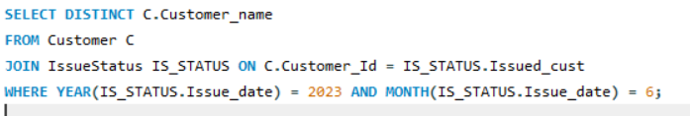

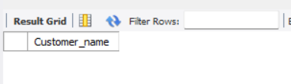

**(No customers who have issued books in June 2023.)**

9. Retrieve book_title from book table containing history.

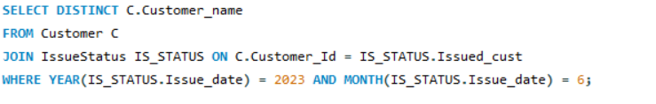

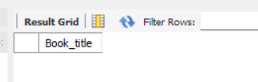

**(No books with title which contains the word “history”.)**

10.Retrieve the branch numbers along with the count of employees for branches having more than 5 employees.

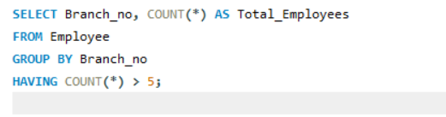

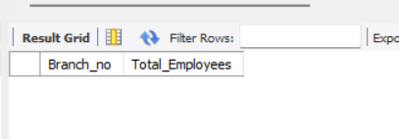

**(No branch is having more than 5 employees.)**

11. Retrieve the names of employees who manage branches and their respective branch addresses.

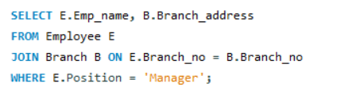

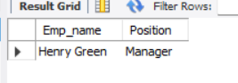

12.  Display the names of customers who have issued books with a rental price higher than Rs. 25.

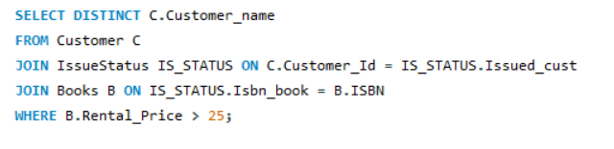

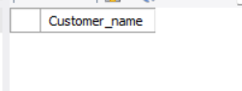

**(No books with rental price more than rs.25)**

Score Distribution:  
1 point for correctly formulating the query of each question (12 x 1 = 12).  
1 point for providing screenshots of the output for each question (12 x 1 = 12).  
1 point for timely submission.  
Total = 25.